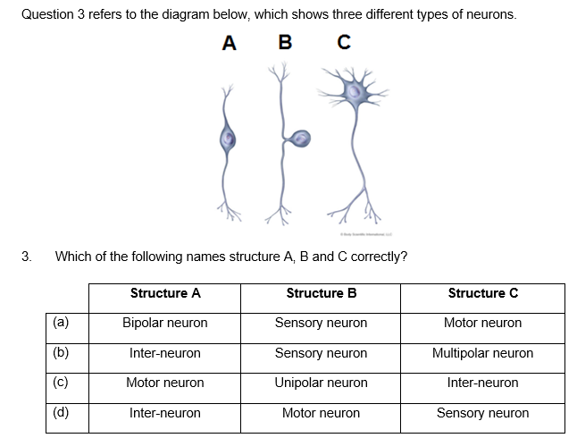

Below is a diagram of a neuron.

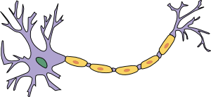

**B**

**C**

**A**

1. Name the structure A and describe its role (2 marks)

______________________________________________________________________________________________________________________________________________________________

1. What is the name and function of the cells labelled “B”? (2 marks)

______________________________________________________________________________________________________________________________________________________________

1. What is the neurilemma and what is its function? (2 marks)

_______________________________________________________________________________

_______________________________________________________________________________



Below is a diagram of a neuron.



**B**

**C**

**A**

1. Name the structure A and describe its role (2 marks)

______________________________________________________________________________________________________________________________________________________________

1. What is the name and function of the cells labelled “B”? (2 marks)

______________________________________________________________________________________________________________________________________________________________

1. What is the neurilemma and what is its function? (2 marks)

_______________________________________________________________________________

_______________________________________________________________________________